Jkuat Work

## Data

## Summary Statistics for water quality

| **Characteristic** | **Afternoon**, N = 28 | **Morning**, N = 28 |
| --- | --- | --- |
| Temp | 29.66 + 1.15 | 23.65 + 1.11 |
| PH | 7.86 + 0.20 | 7.62 + 0.19 |
| D.O | 7.63 + 0.23 | 8.58 + 0.58 |
| TAN | NA + NA | 0.2000 + 0.0000 |
| NO3 | NA + NA | 10.0000 + 0.0000 |
| NO2 | NA + NA | 0.0100 + 0.0000 |

### Water Quality across sampling Months

| **Parameters** | **Jul** | **Aug** | **Sep** | **Oct** | **Nov** | **Dec** |
| --- | --- | --- | --- | --- | --- | --- |
| Temp | 27.59 + 3.19 | 26.46 + 3.33 | 27.02 + 3.26 | 26.99 + 3.83 | 26.07 + 3.19 | 26.28 + 3.35 |
| PH | 7.75 + 0.21 | 7.73 + 0.19 | 7.75 + 0.21 | 7.67 + 0.24 | 7.75 + 0.24 | 7.76 + 0.28 |
| D.O | 7.92 + 0.47 | 8.15 + 0.49 | 8.00 + 0.49 | 7.93 + 0.95 | 8.17 + 0.49 | 8.32 + 0.85 |
| TAN | 0.20 + 0.0 | 0.20 + 0.0 | 0.2 + 0.0 | 0.20 + 0.0 | 0.2 + 0.0 | 0.2 + 0.0 |
| NO3 | 10.0 + 0.0 | 10 + 0 | 10+ 0 | 10 + 0 | 10+ 0 | 10 + 0. |
| NO2 | 0.01 + 0 | 0.01 + 0 | 0.01 + 0 | 0.01 + 0 | 0.01 + 0 | 0.01 + 0.0 |

## Plots

##### Physiochemical parameters across sampling months

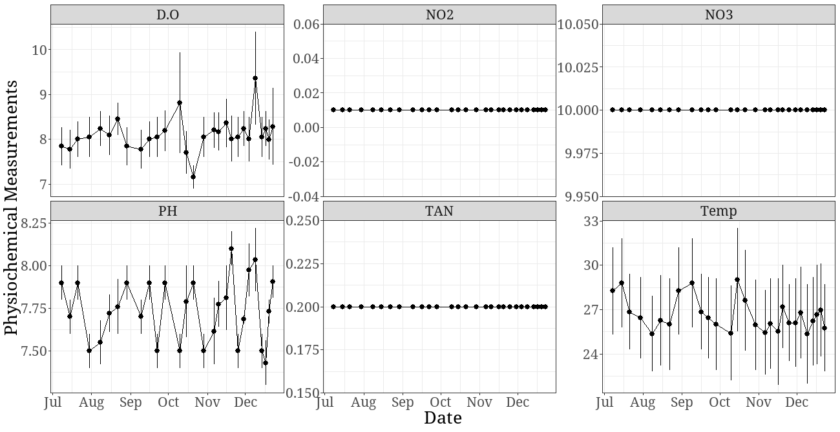

## Bar Graphs

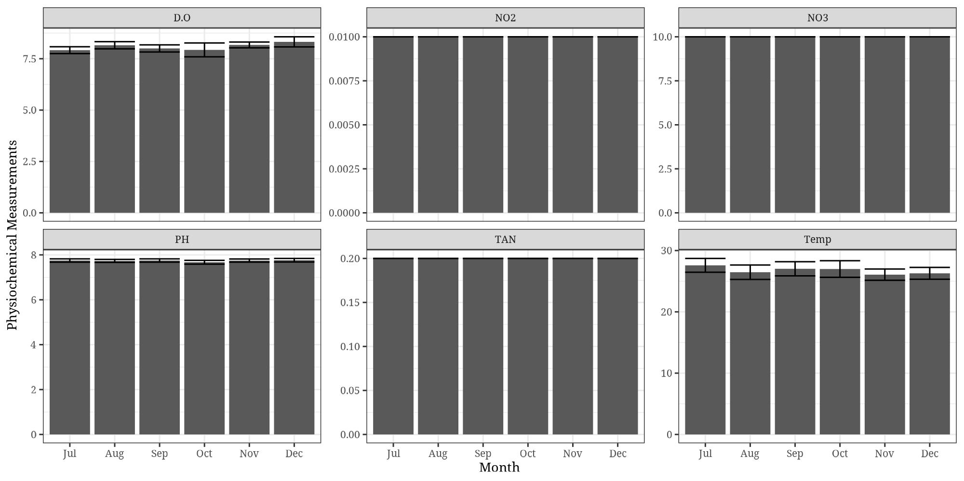

## Stacked bar charts

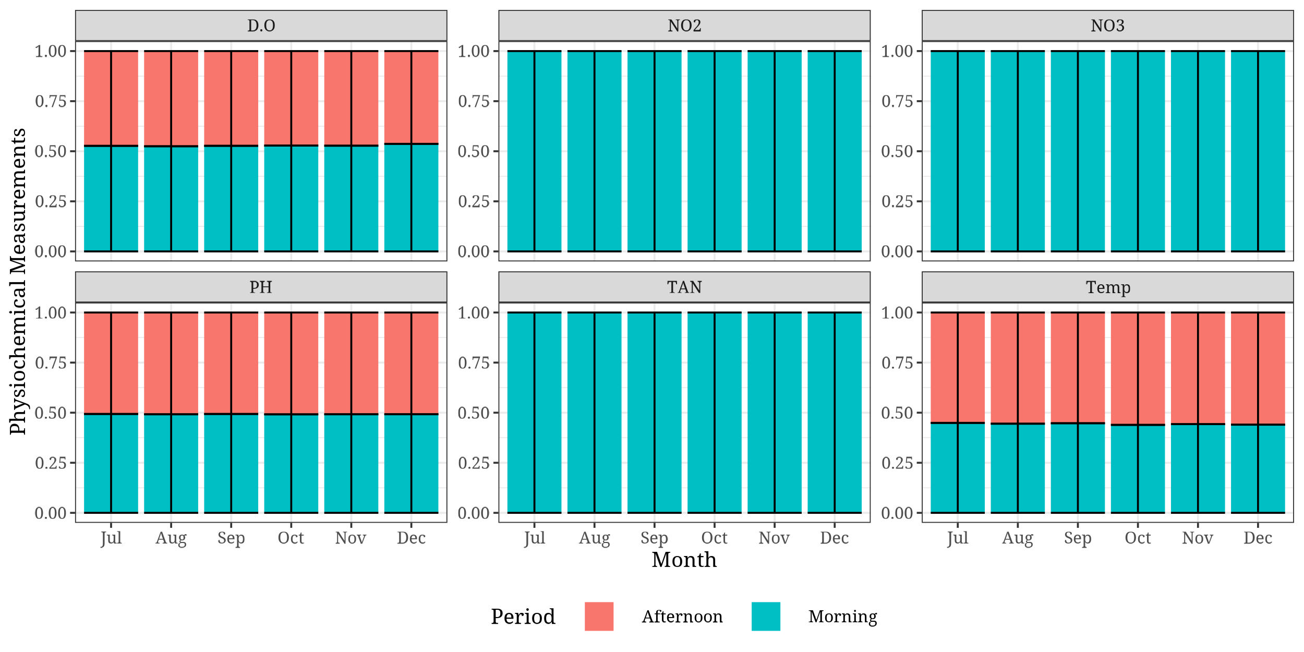

## Dodged bar charts

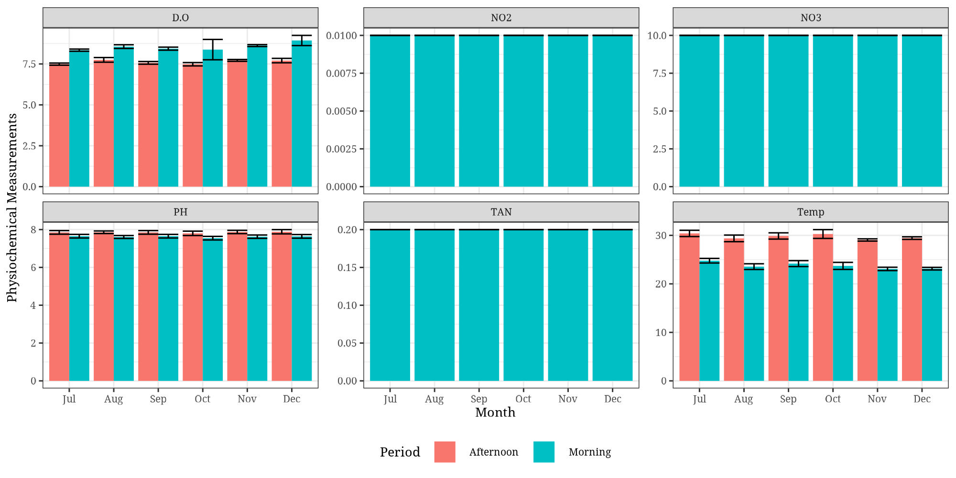

Temperature

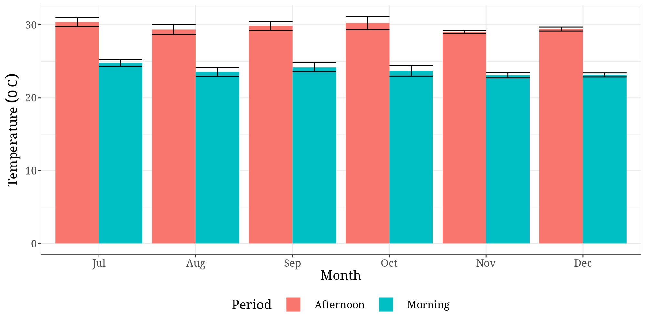

Temperature stacked

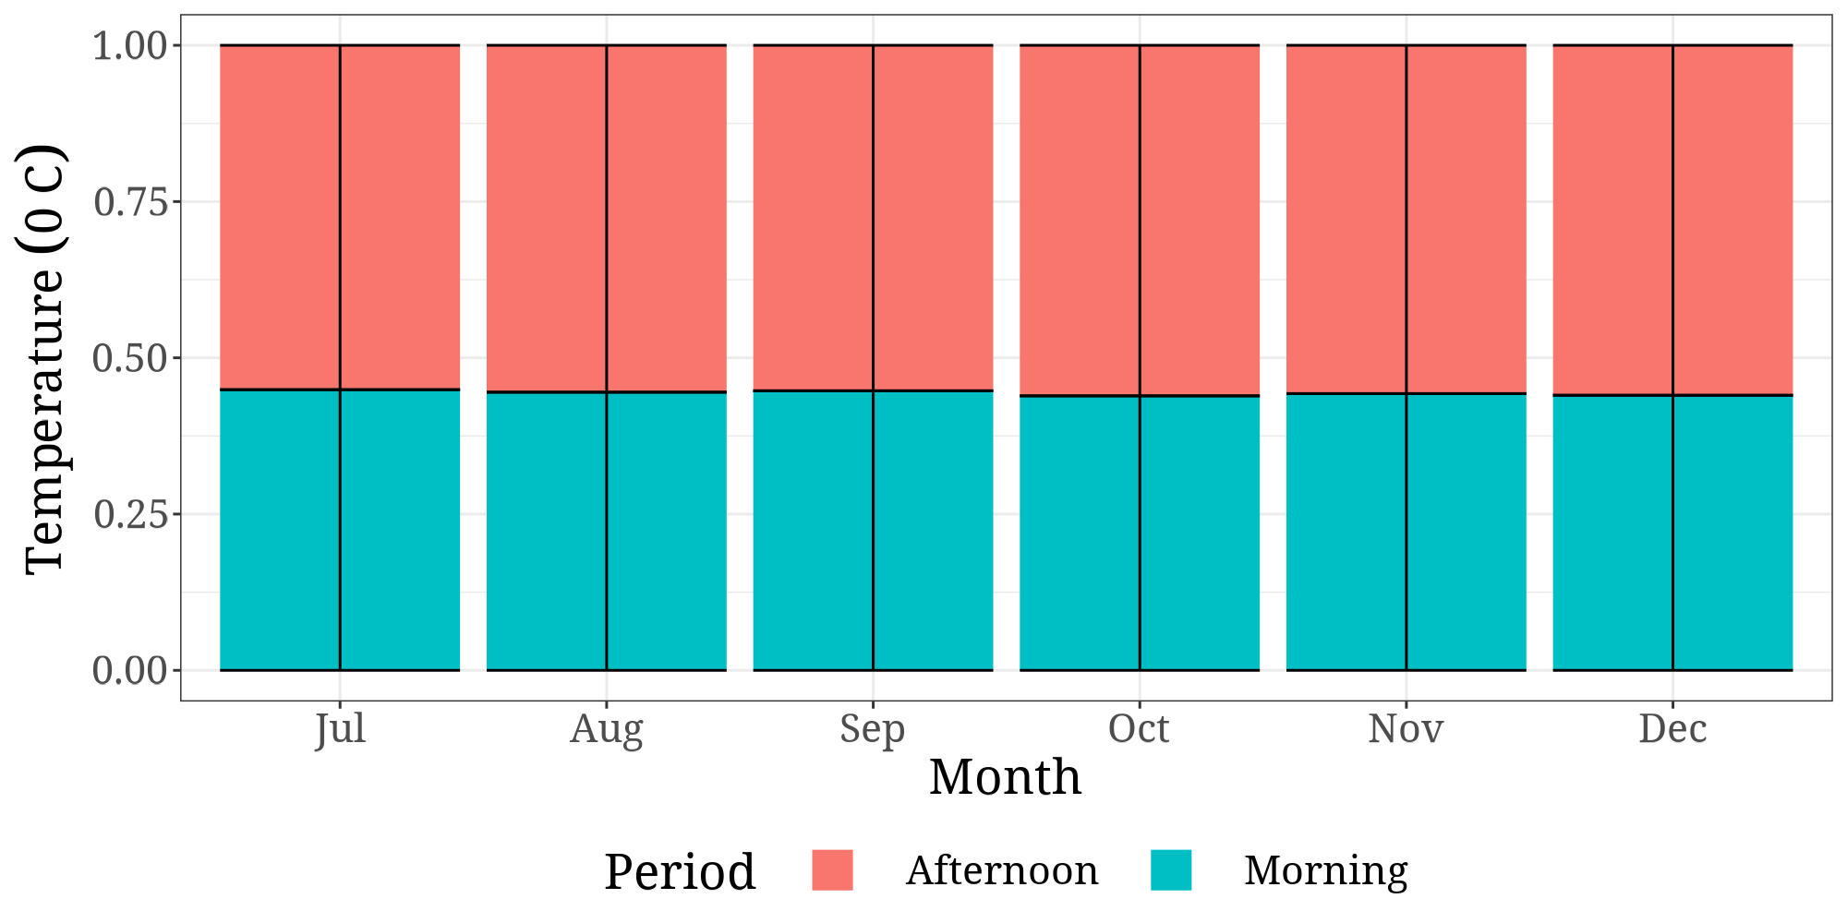

Temperature

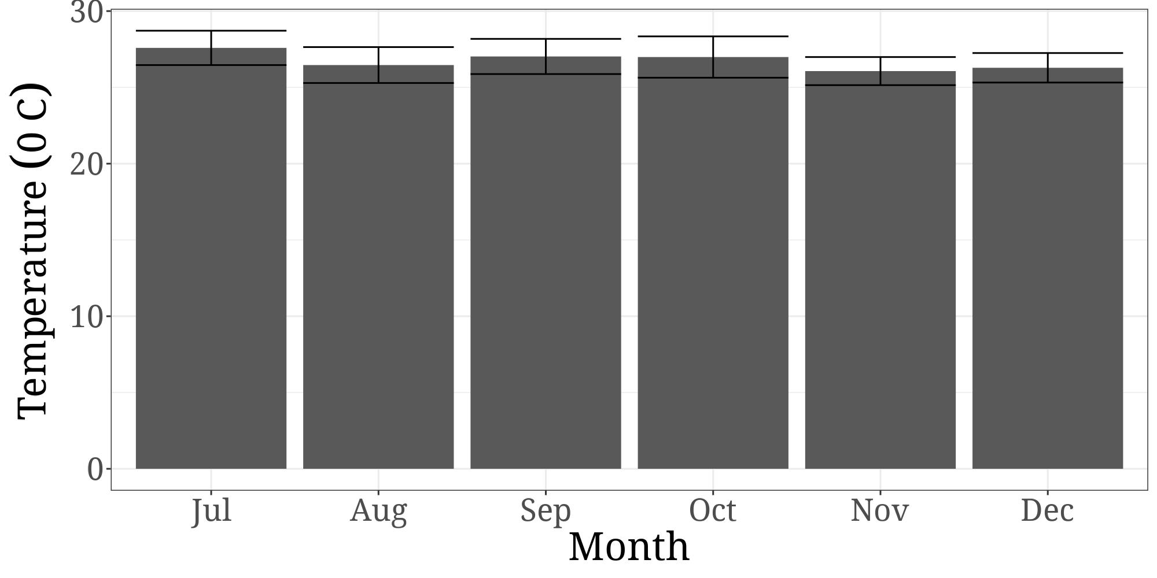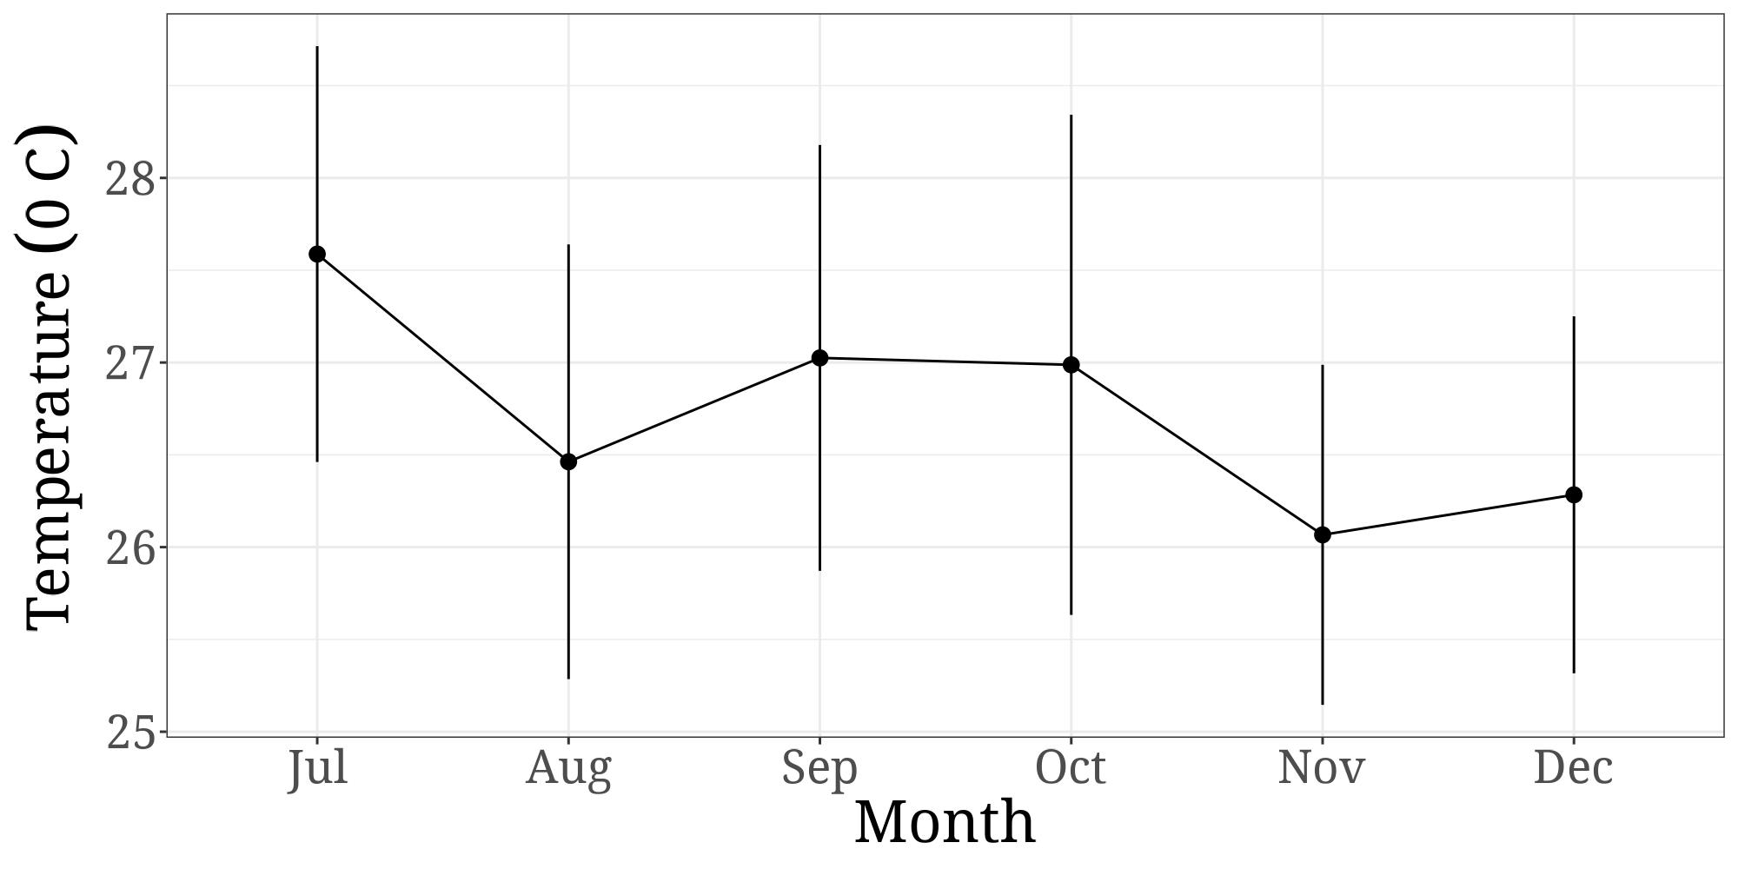

Ph

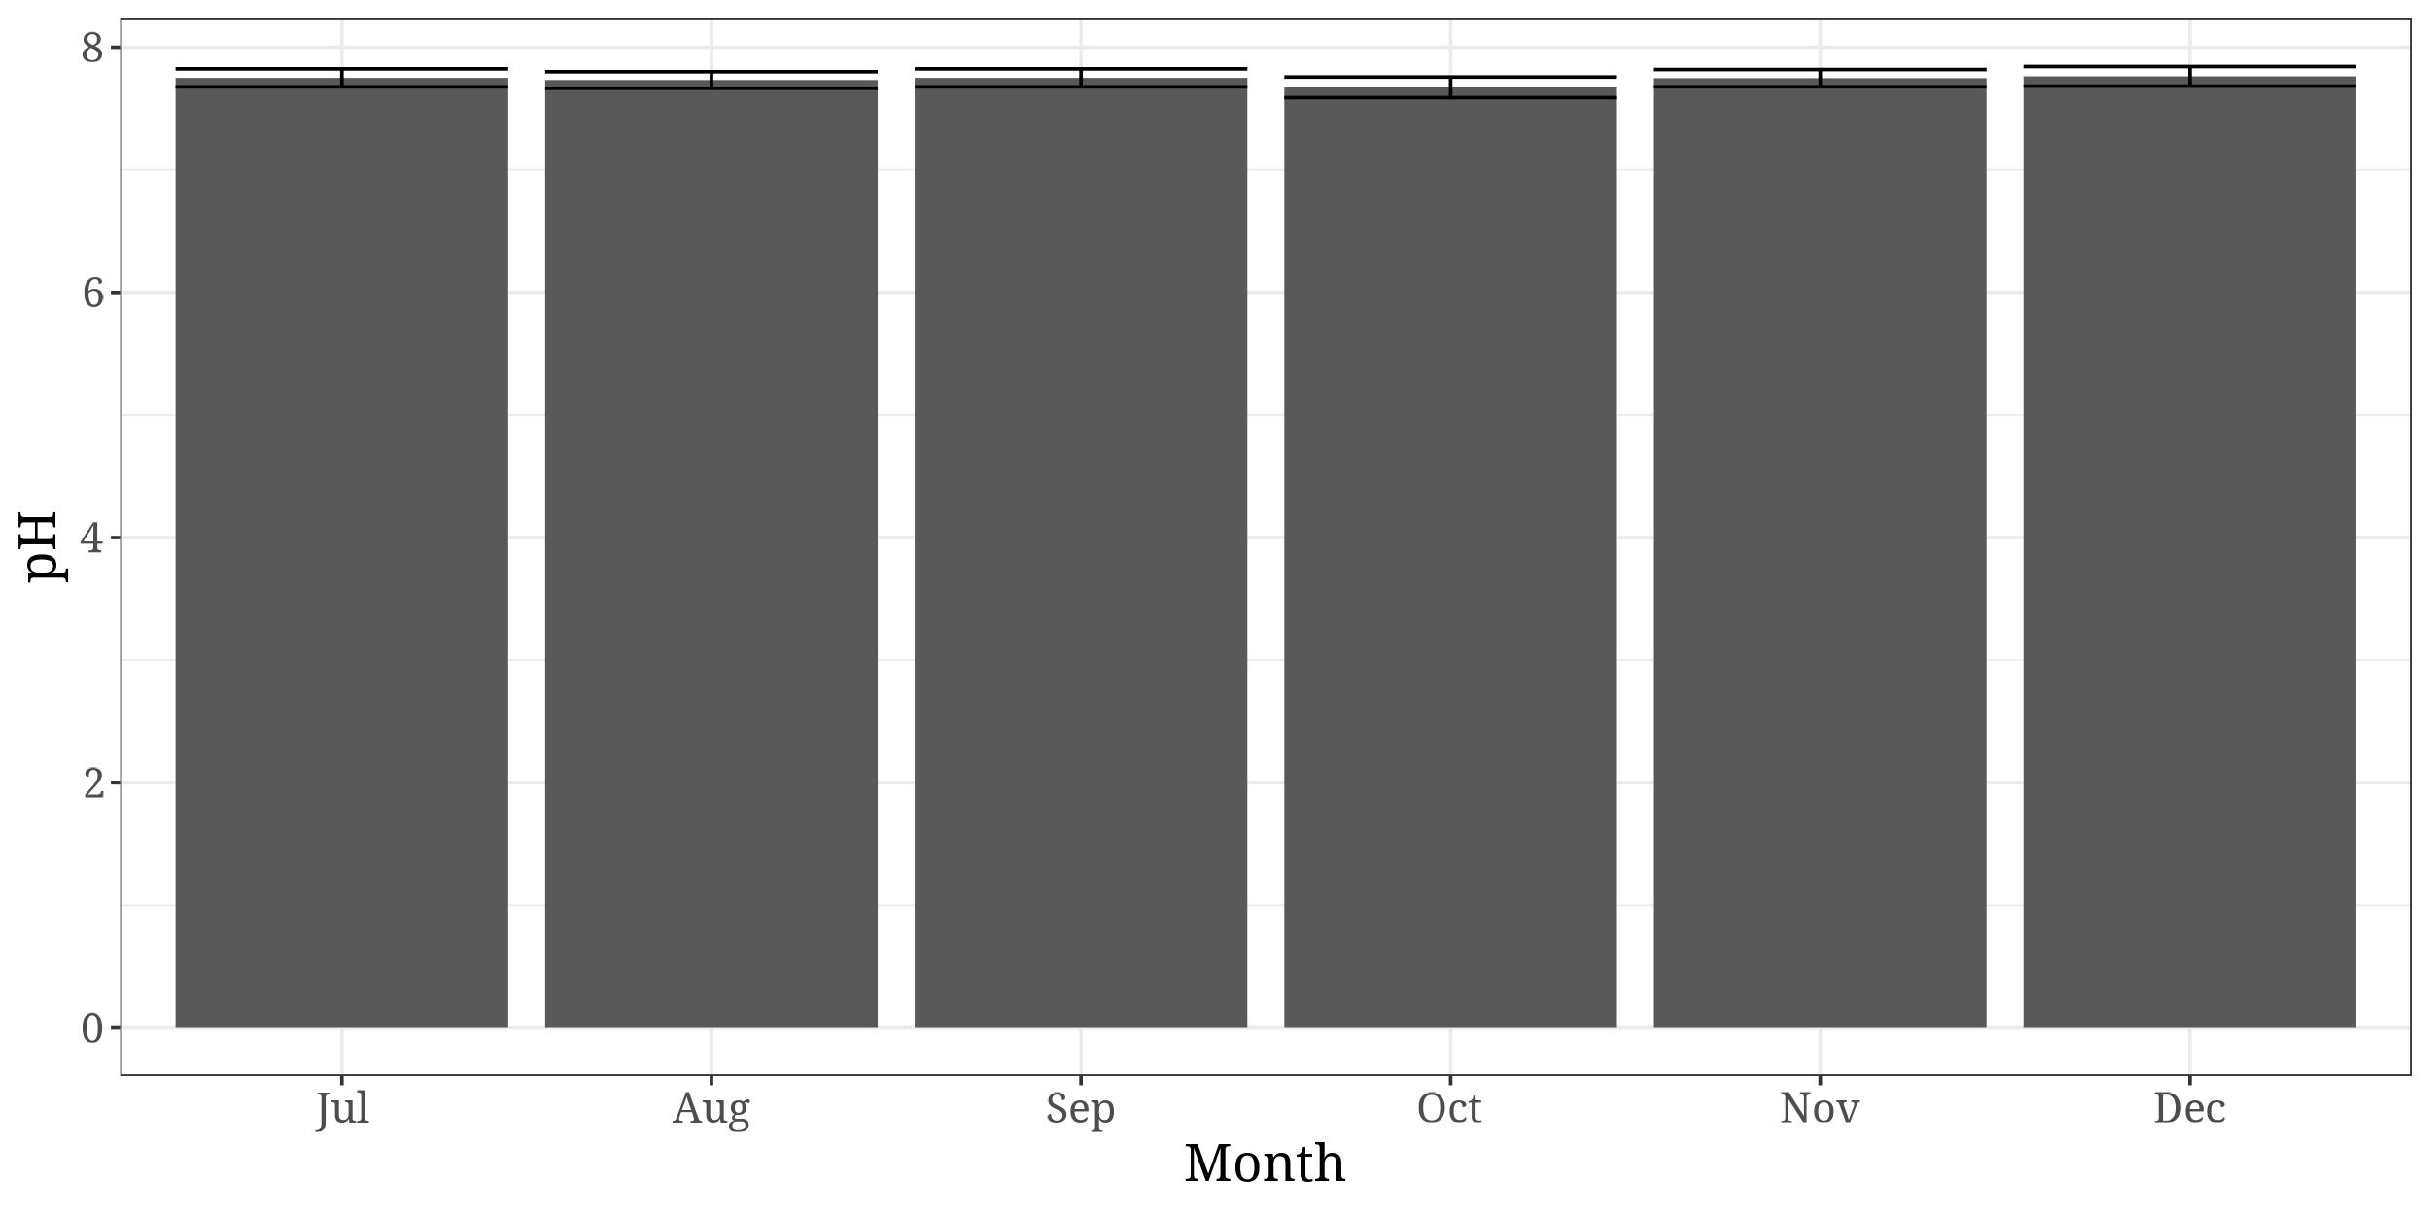

Ph period

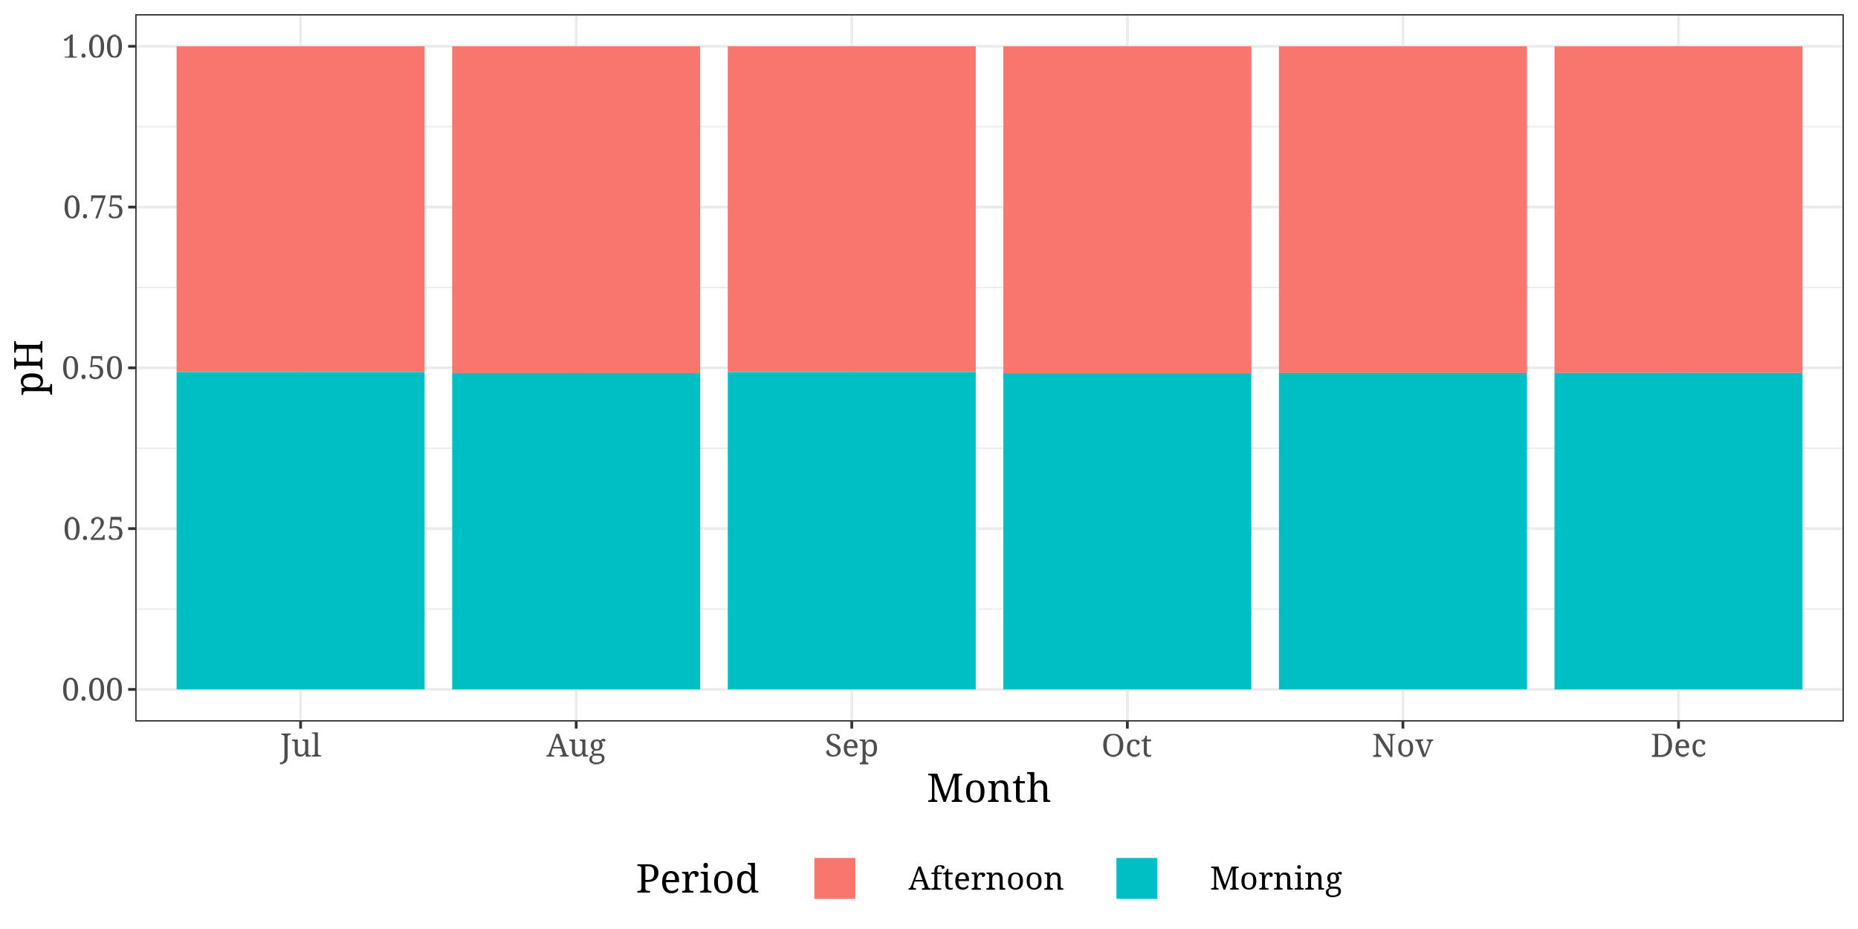

Dissolved Oxygen

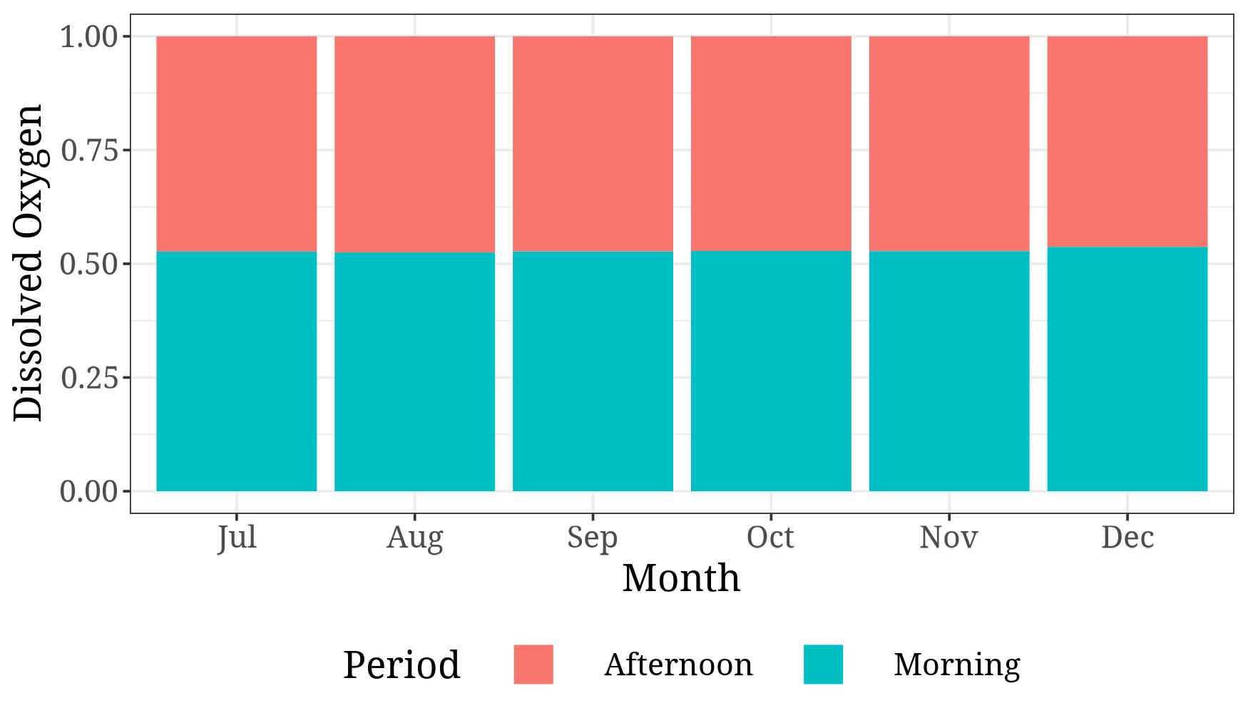

Dissolved Oxygen

